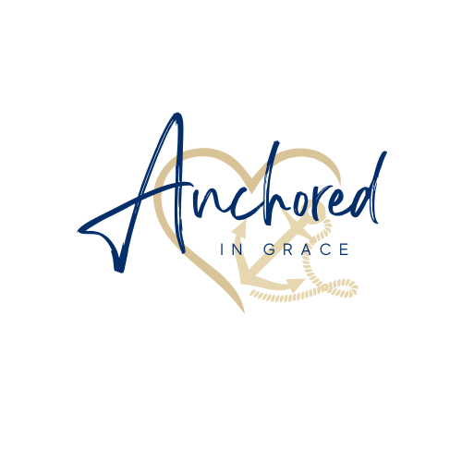
Small Business Sponsorship Opportunities

YES! I’d like to become a Small Business Sponsor by investing in Anchored in Grace Foundation with a donation of $100 or more.

Business Name: _____________________________________________________________

Mailing Address: ____________________________________________________________
____________________________________________________________

Contact Person: ____________________________________________________________

Phone: ______________________________ email: _______________________________

Sponsorship Amount: (Please check donation amount)
_____ $100
_____$200
_____$300
_____$400
_____$450
_____ Other: Amount of sponsorship: $______________

Please mail this form with your business check to:
Mysi Fortenbery
Anchored in Grace Foundation
PO Box 74
Nashville, NC 27856

Tax ID #: 93-2132704. Anchored in Grace Foundation, Inc. is a qualified 501c3 tax-exempt organization and donations are tax- deductible to the full extent of the law. Please consult your tax advisor regarding specific questions about your deductions.

